hw #20/Post-Modernism
Part One:
Phillip Glass is a contemporary composer who is associated with the minimalist movement. The music in this discourse is a composition by Phillip Glass and the soundtrack for the movie, “The Hours” a movie based on a book by author Michael Cunningham. His book was directly influenced by Virginia Woolf’s, “Mrs. Dalloway”. Minimalist music is characterized by the following: steady pulse, repeat phrases, transformation, and hypnotic forward motion. Describe “The Hours” considering the aforementioned. Do you hear consonance or dissonance in this piece? How would you describe the texture and timbre? I suggest that you put the video on, then sit back, close your eyes and enjoy. Then, look at the video and watch what the right and left hands are playing. People tend to either love the minimalist music of Glass or hate it. How do you feel about this particular piece of minimalist music?
Phillip Glass: “The Hours” Do a web-search for “The Hours” Live on Grand Piano.

Part Two:
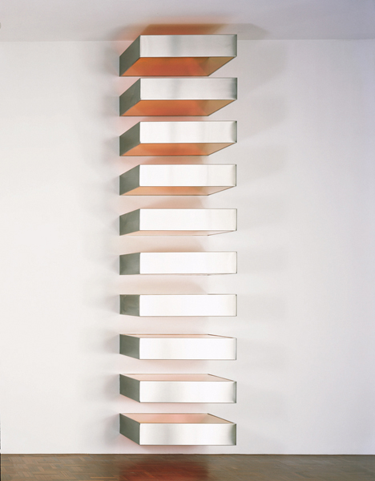

Cut and paste the links below for reading on the Minimalist sculptor Donald Judd. Describe the sculpture Untitled (1980) and explain the Minimalist art of Donald Judd.

https://www.moma.org/learn/moma_learning/donald-judd-untitled-stack-1967
http://www.theartstory.org/artist-judd-donald-artworks.htm

Note: You should be able to answer Part One and Part Two (combined) in one page.

